**Power BI Report Integration Using ReactJS**

In this article, you will learn how to integrate Power BI report or dashboard using ReactJS framework.

**Step 1: Register an application with Azure AD and create a service principal**

1. Sign-in to the Azure poral (<https://portal.azure.com>)
2. Search for and select **Azure Active Directory**.
3. Select **App registrations**, then select **New registration**.
4. Name the application, for example “Finance Model App Integration”.
5. Select a supported account type, which determines who can use the application. In our case, select “Accounts in this organizational directory only” which is default one.
6. Ignore Redirect URI.
7. Select **Register**.

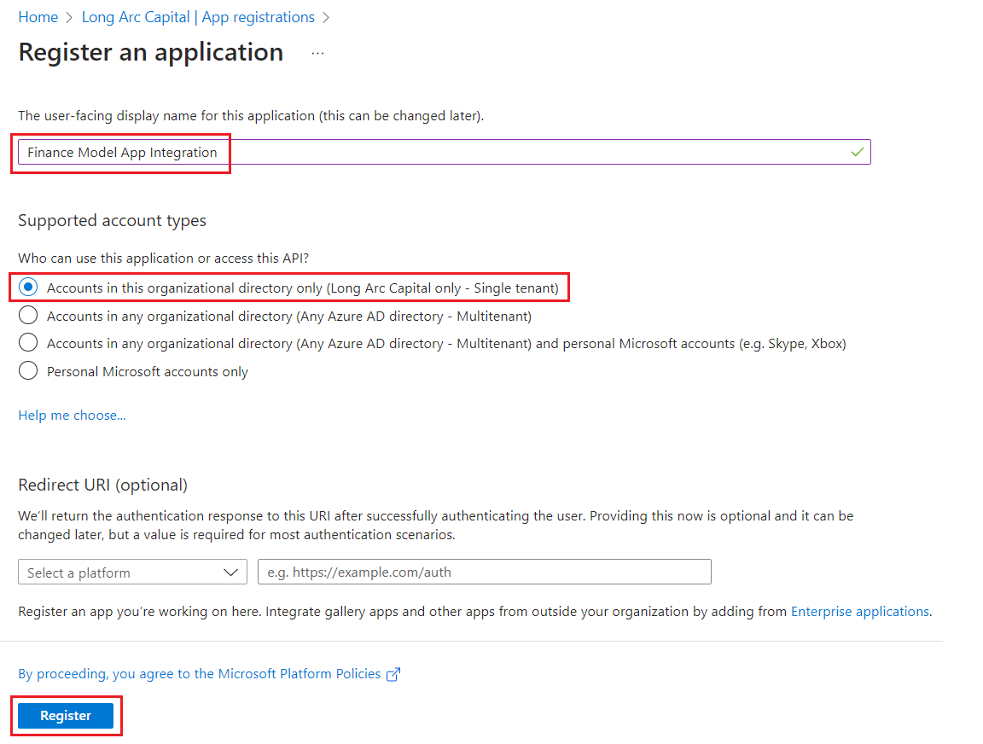

You have created your Azure AD application and service principal.

**Step 2: Add a client secret**

1. Search for and select **Azure Active Directory**.
2. Select **App registrations**, then select newly created application (Finance Model App Integration).
3. Search for and select **Certificates & secrets**, then select **New client secret**.
4. Enter a description for this client secret and set a expiry**.**
5. Select **Add**.

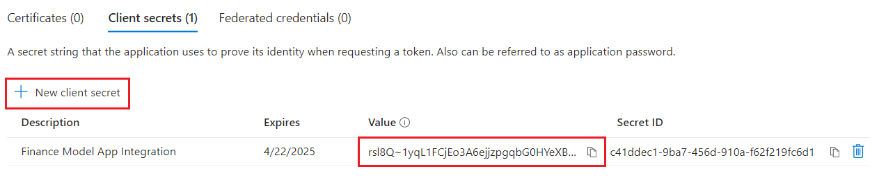

Copy the below information and keep with you for the next steps.

* Application (Client) Id
* Tenant Id
* Application (Display) Name
* Client Secret

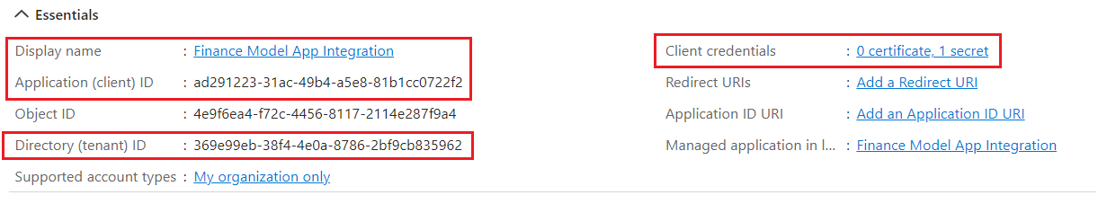

**Step 3: Configure API Permissions**

1. Search for and select **Azure Active Directory**.
2. Select **App registrations**, then select newly created application (Finance Model App Integration).
3. Search for and select **API permissions**, then select **Add a permission**.
4. Select **Microsoft APIs**, then select **Microsoft Graph.**
5. Select **Delegated permissions**.
6. Search for and select **User.Read** under User permission section.
7. Select **Add permissions**.
8. Select Grant admin consent for Long Arc Capital, then select **Yes** from Grant admin consent confirmation.

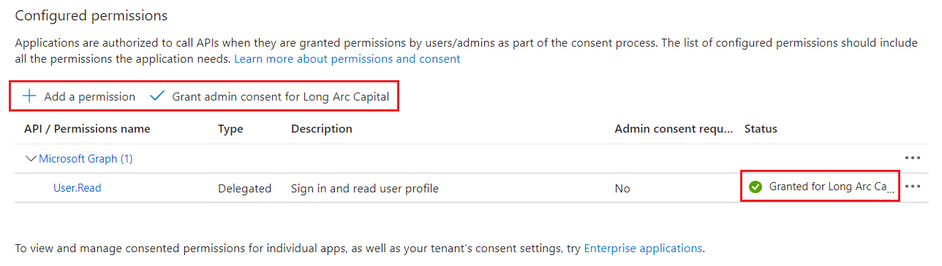

**Step 4: Create Azure AD Group**

1. Search for and select **Groups**.
2. Select **New group**.
3. Select **Group type** as Security.
4. Enter the name of the group, for example “Finance Model App Group”**.**
5. Enter a description of the group.
6. Select **No** for Azure AD roles can be assigned to the group.
7. Select **Membership type** as Assigned.
8. Select **Create**.

**Step 5: Add Members to Azure AD Group**

1. Search for and select **Groups**.
2. Search for and select **Finance Model App Group** (newly created group).
3. Select **Members**, then select **Add members**.
4. Search for and select **Finance Model App Integration** (newly created service principal)**.**
5. Make sure selected items are added below.
6. Click **Select**.

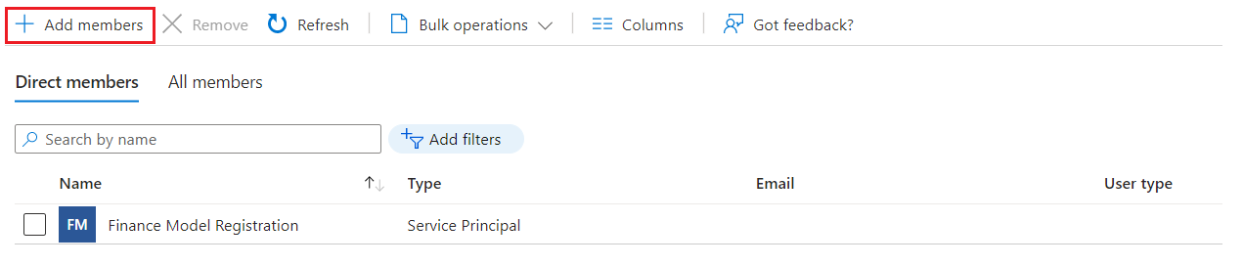

**Step 6: Add Azure AD group to specific security group in Power BI**

1. Sign-in to the Power BI (<https://app.powerbi.com>)
2. Click on three dots (…) and select **Settings**, then select **Admin portal.**
3. Select **Tenant settings** and go to **Developer settings**.
4. Toggle the **Enabled** slider under “Allow service principals to use Power BI APIs”.
5. Next, apply it to a “Specific security groups (Recommended)”, and add the security group you created (currently called **Finance Model App Group**).
6. Select **Apply**.

After clicking apply, the following message should appear. Keep in mind that this can have almost immediate effect or take as much as 15 minutes to complete.

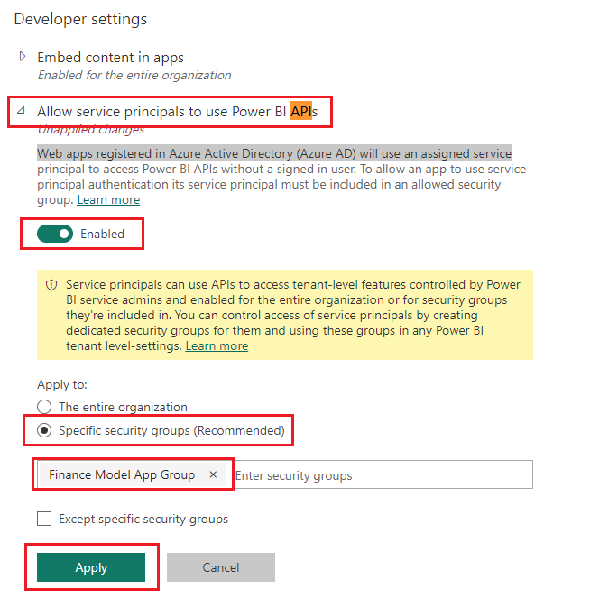

**Step 7: Grant access in workspaces in Power BI**

1. Go to Power BI home page, then select **Workspaces**.
2. Search for select your workspace.
3. Select **Access.**
4. Enter security group name (Finance Model App Group) and select **Admin** permission.
5. Select **Add.**
6. Enter service principal name (Finance Model App Integration) and select **Member** permission.
7. Select **Add**, then select Close**.**

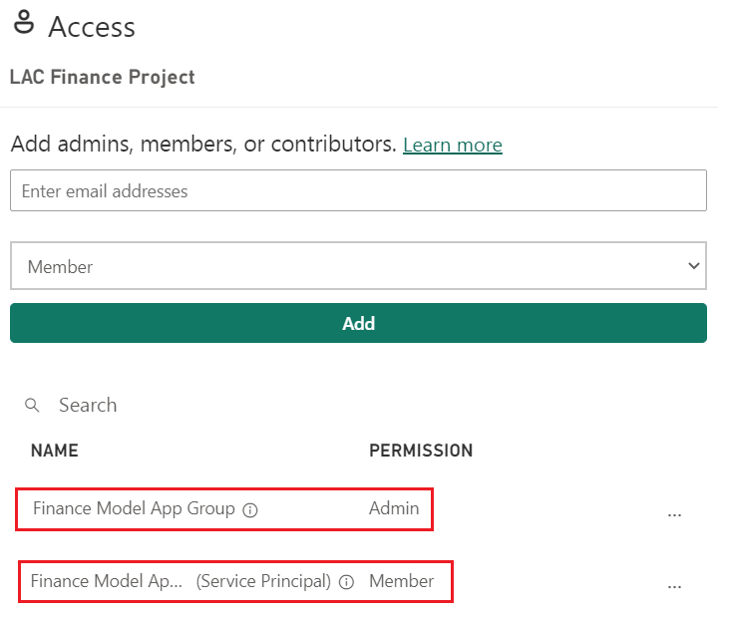

**Step 8: Generate Power BI Embedding URL**

1. Go to Power BI rest API link (<https://learn.microsoft.com/en-us/rest/api/power-bi/reports/get-report-in-group>).
2. Select **Try It** Rest API.
3. Sign-in to the account using credentials**.**
4. Pass **groupId** and **reportId** under Parameters section.

Note: You can copy groupId and reportId from Power BI workspace report url.

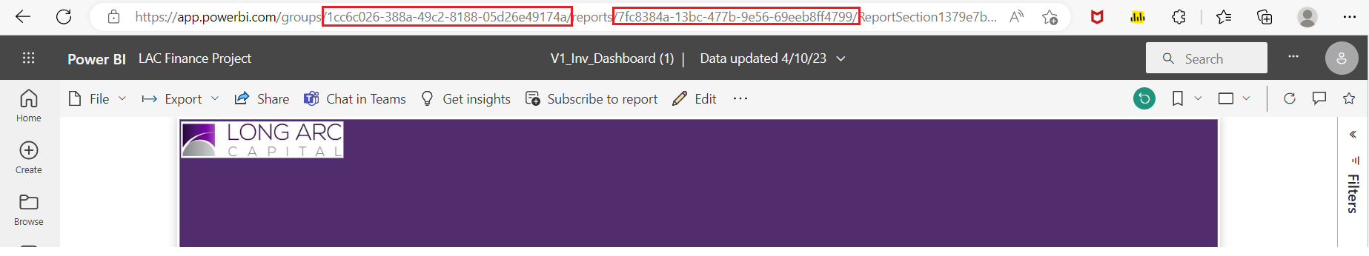

1. Select **Run.**
2. Copy **embedUrl** from body section and keep with you for next steps.

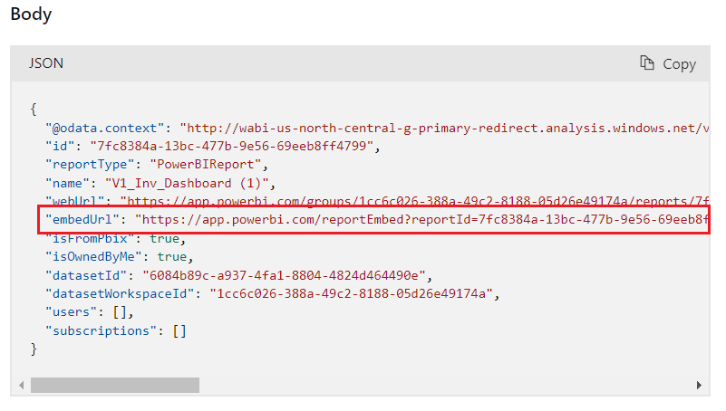

**Step 9: Generate Power BI Access Token using Rest API**

1. To start, make an HTTP Post call to the following URL:

<https://login.microsoftonline.com/tenant_id/oauth2/v2.0/token>

replace **tenant_id** with generated Directory (tenant) ID in **Step 2.**

1. Input in the following parameters, using a x-www-form-urlencoded object in the body:

**Sample Request:**

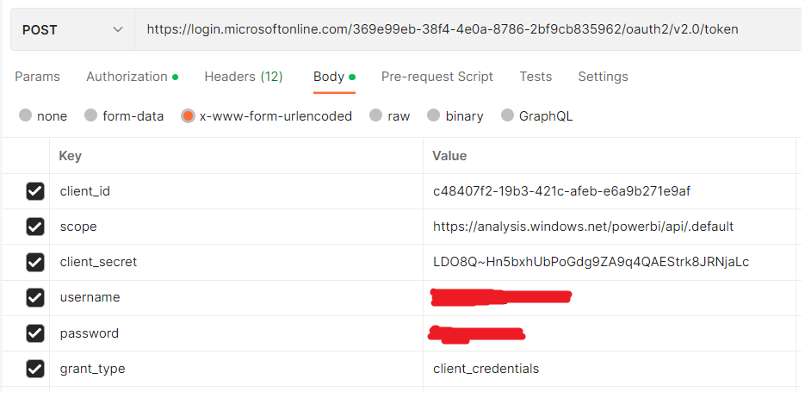

* Use Azure portal credentials for username and password params.
* Replace client_id, client_secret values generated in **Step 2**.

**Sample Response (accessToken):**

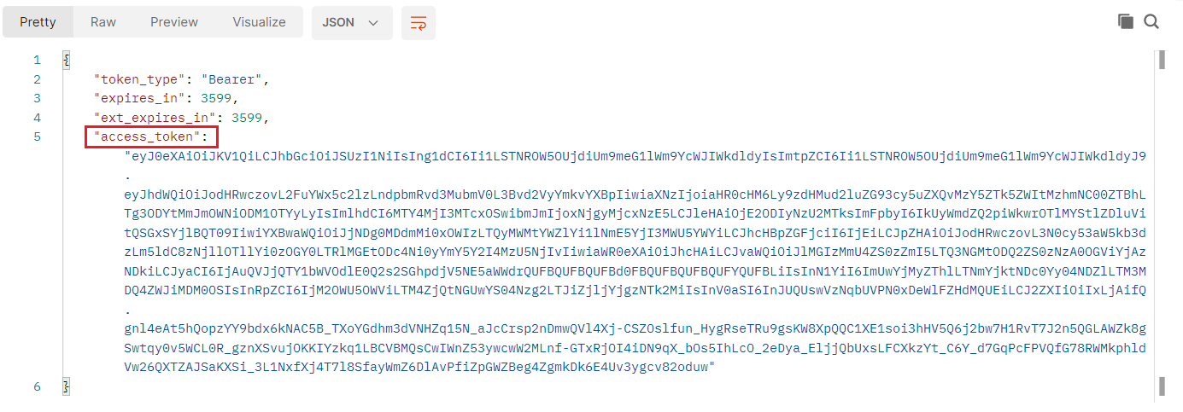

This access_token is only valid for 1 hour.

**Step 9: Generate Power BI Embed Token using Rest API**

1. To start, make an HTTP Post call to the following URL:

<https://api.powerbi.com/v1.0/myorg/groups/groupId/reports/reportId/GenerateToken>

replace **groupId** and **reportId** from Power BI workspace report url (refer Step 8)

1. Input in the following parameters, using a JSON object in the body and Bearer Token (Access Token generated in Step 8) in the authorization.

**Sample Request:**

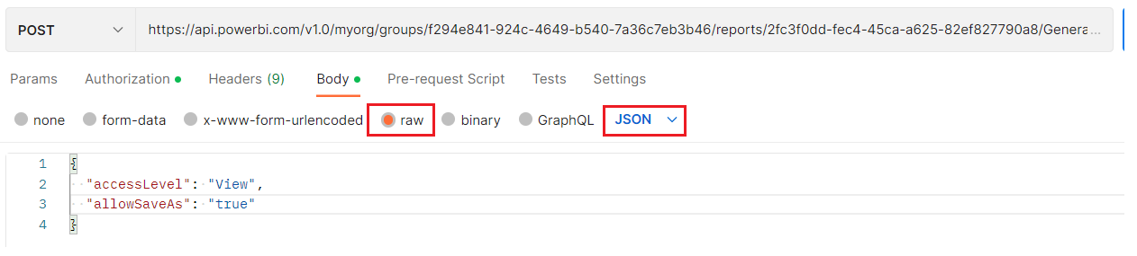

Use Access Token generated in Step 8 as Bearer Token in authorization.

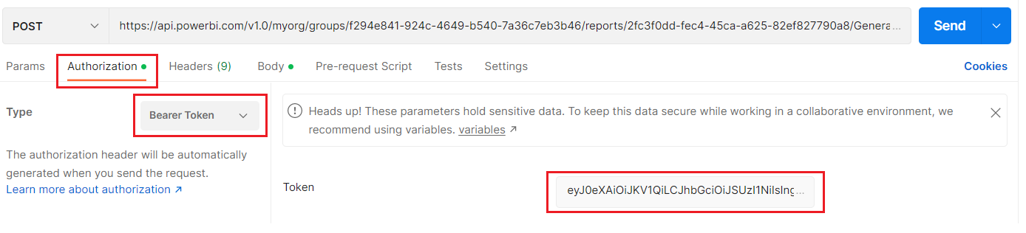

**Sample Response (embedToken):**

This embedding token is needed when loading Power BI dashboard in web application.

**Step 10: Embed Power BI Report in ReactJS**



Replace reportId, embedUrl and embedToken and run the application.